**Git and GitHub Installation Guide**

**Git Installation on Windows :**

**Download Git for Windows**

Step 1 : Browse to the official Git website:<https://git-scm.com/downloads>

Step 2 : Click the download link for Windows and allow the download to complete.

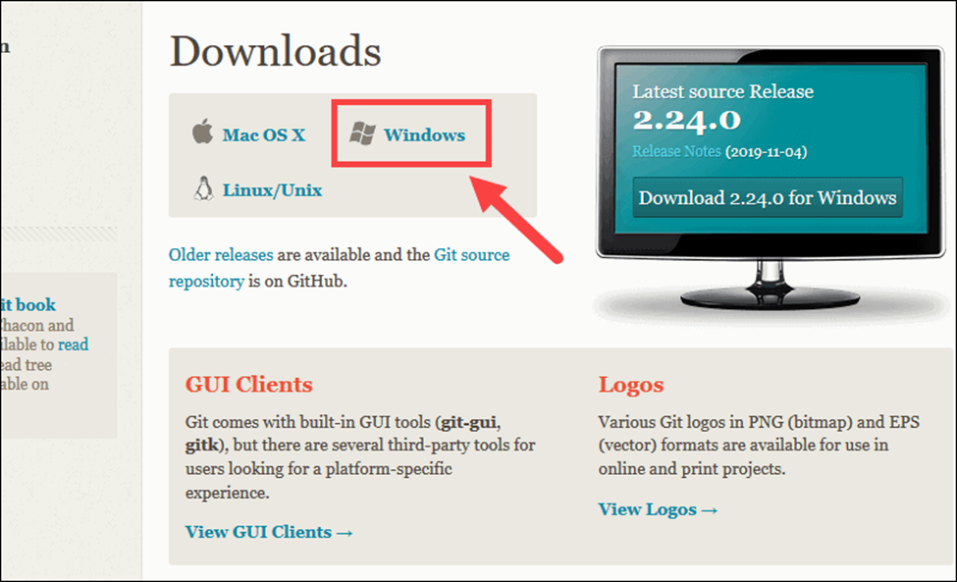

**Step 3 : Browse to the download location (or use the download shortcut in your browser). Double-click the file to extract and launch the installer.**

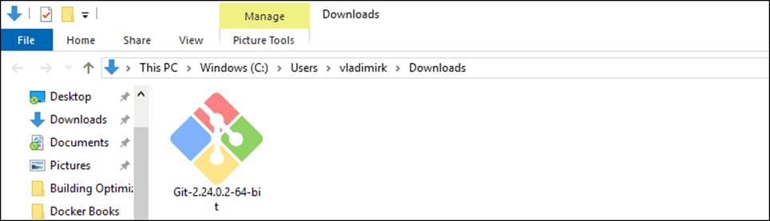

**Step 4 : Double click on the installer and Review the GNU General Public License, and when you’re ready to install, click Next.**

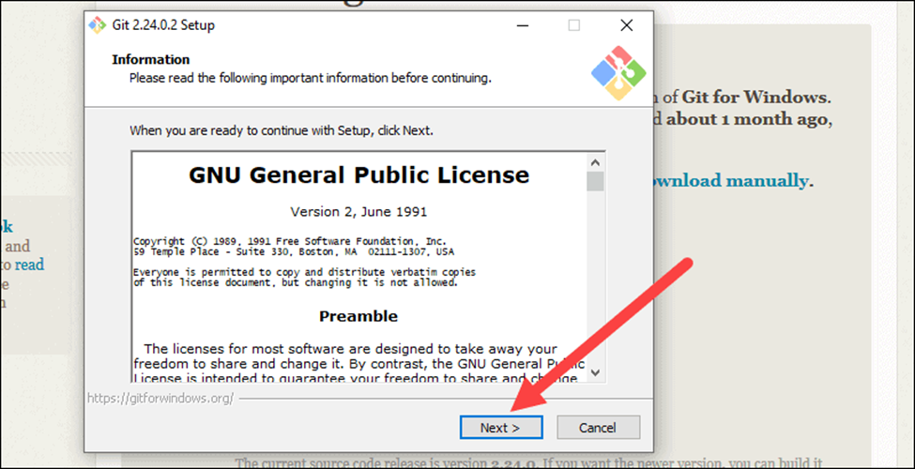

**Step 5 : Choose a location for git installation, you can also choose to keep default and click on next.**

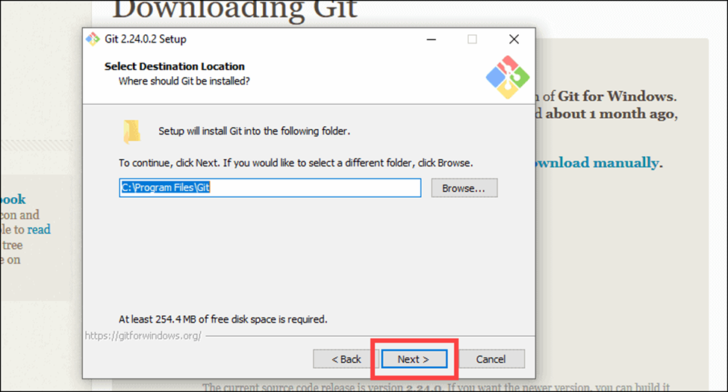

**Step 6: A component selection screen will appear. Leave the defaults unless you have a specific need to change them and click Next.**

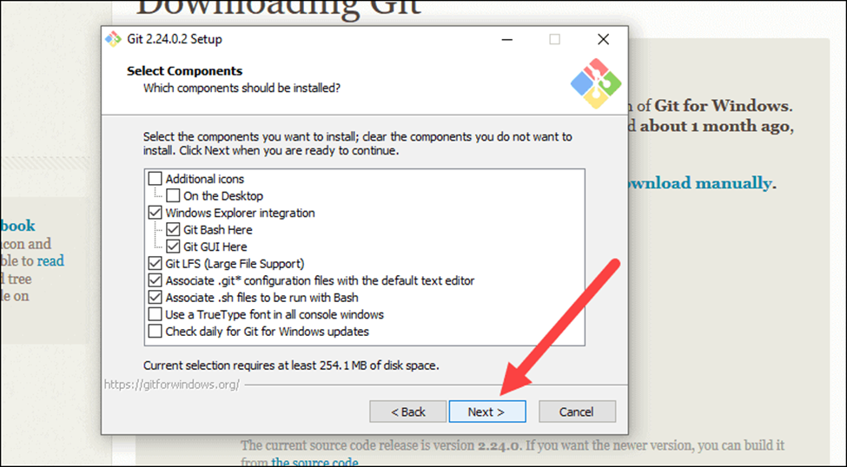

**Step 7 : Keep clicking on Next with default settings as shown below.**

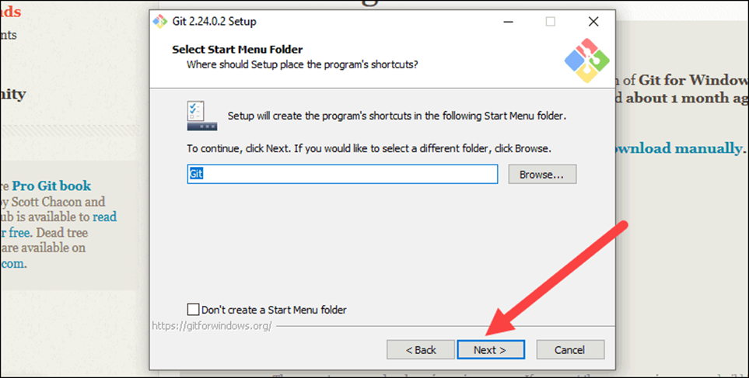

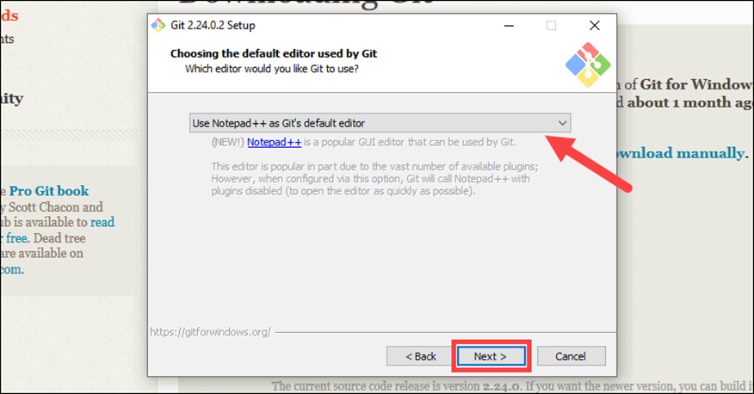

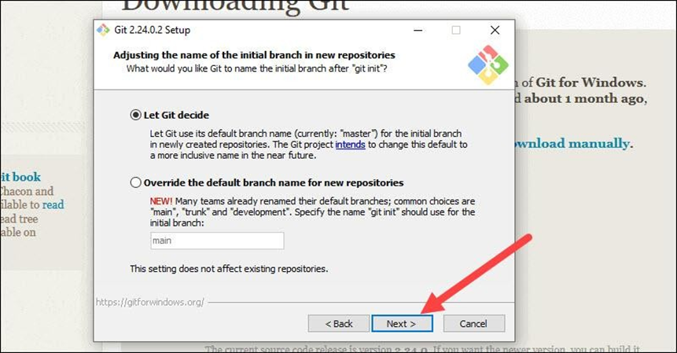

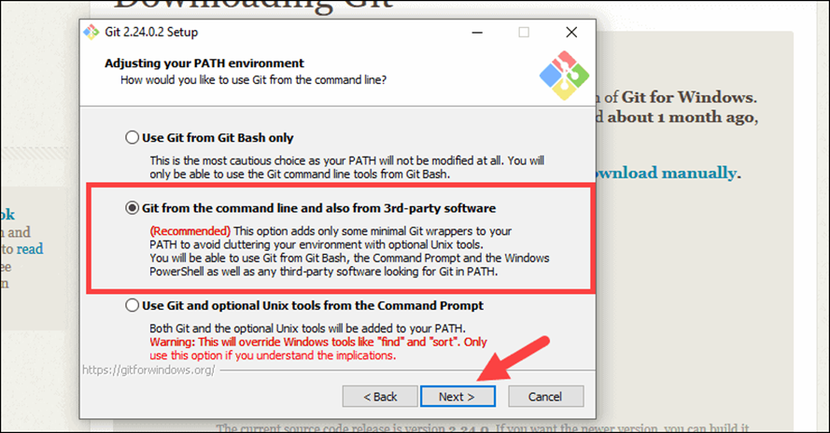

**Step 8 : The installer now asks which SSH client you want Git to use. Git already comes with its own SSH client, so if you don't need a specific one, leave the default option and click Next.**

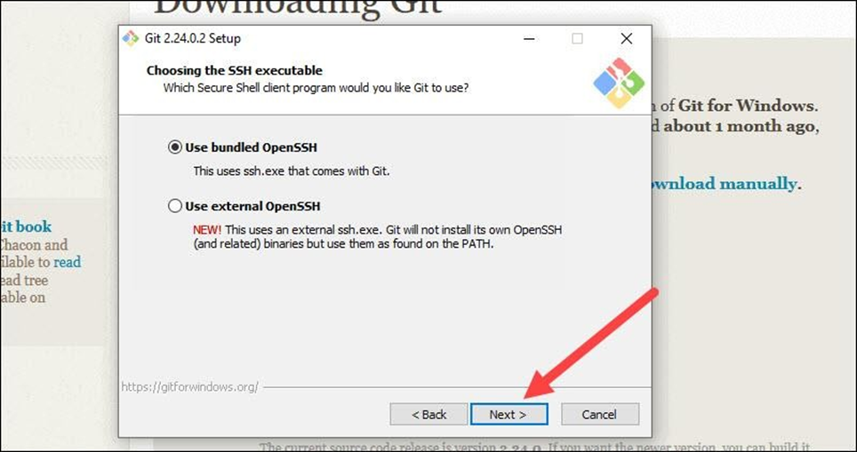

**Step 9 : The next option relates to server certificates. Most users should use the default. If you’re working in an Active Directory environment, you may need to switch to Windows Store certificates. Click Next.**

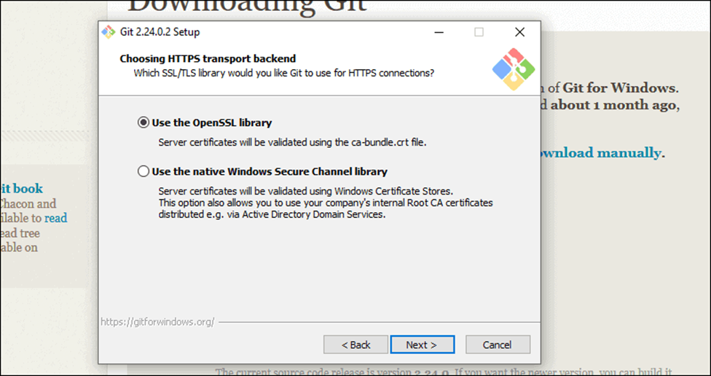

**Step 10 : The next selection converts line endings. It is recommended that you leave the default selection. This relates to the way data is formatted and changing this option may cause problems. Click Next.**

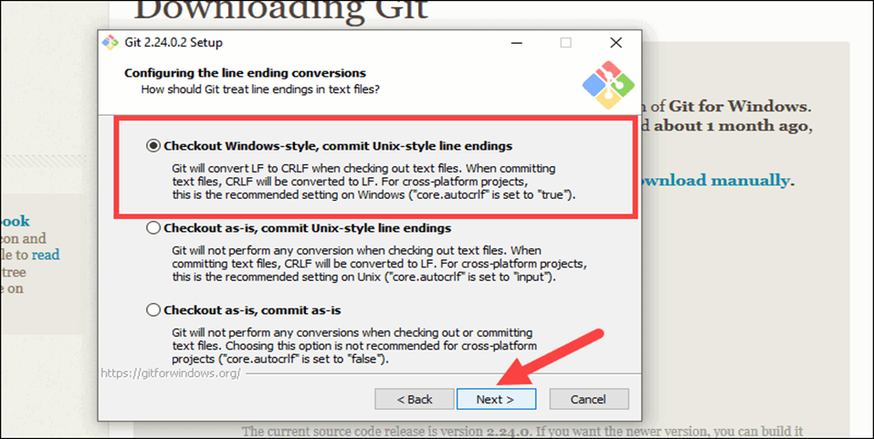

**Step 11 : Choose the terminal emulator you want to use. The default MinTTY is recommended, for its features. Keep clicking on Next with default setting until your installation is complete.**

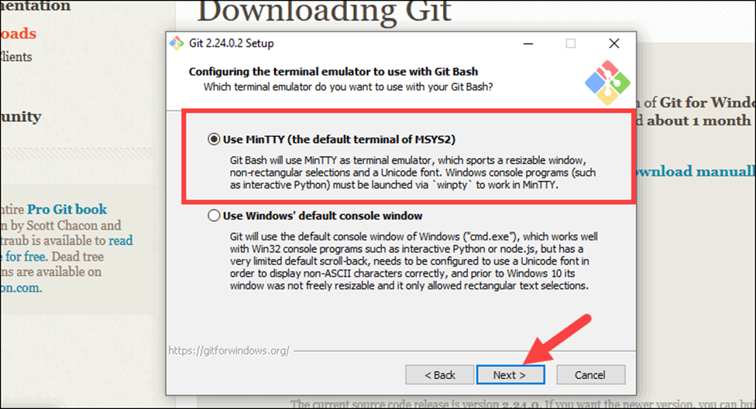

**Step 12 : Once the installation is complete, tick the boxes to view the Release Notes or Launch Git Bash, then click Finish.**

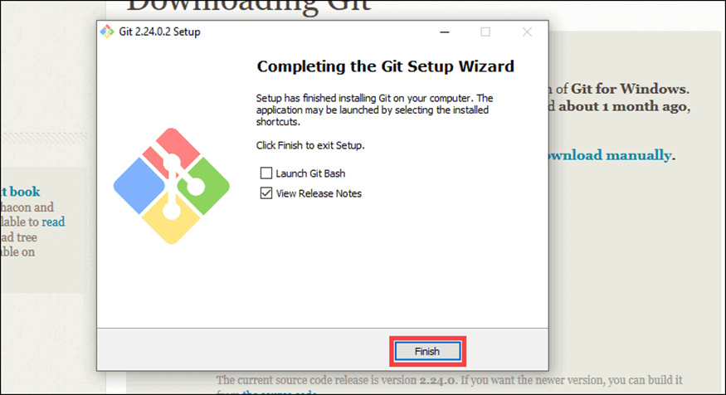

**Setting up a GitHub Account :**

**Step 1 : Open** [**https://github.com**](https://github.com/) **in a browser, and then select Sign up.**

**Step 2 : Enter your email address, username and create password.**

**Step 3 : Verify your account by solving a puzzle. Select the Start Puzzle button to do so, and then follow the prompts.**

**Step 4 : After you verify your account, select the Create account button.**

**Step 5 : Next, GitHub sends a launch code to your email address. Type that launch code in the Enter code dialog, and then press Enter.**

**Step 6 : GitHub asks you some questions to help tailor your experience. Choose the answers that apply to you in the following dialogs:**

**· How many team members will be working with you?**

**· What specific features are you interested in using?**

**Step 7 : On the Where teams collaborate and ship screen, you can choose whether you want to use the Free account or the Team account. To choose the Free account, select the Skip personalization button.**